### 

### What is a Waterfall Process Model?

The waterfall process model has its name waterfall model as each stage constructs a well-defined product or output that is passed onto the next stage as an input, just like a stream of water. Once the stream of waterfalls,, it cannot flow back up. Similarly, in the waterfall model, when one stage passes its product to the next one, the scenario cannot be reverted.

So, we can say that this entire software development process behaves like a series of tiny waterfalls, and this is why we refer to this model as the ‘waterfall model’.

### The waterfall model divides the entire process of software development into a definite number of stages. The developers then carry out these stages in a sequence, one after another. Every stage produces a well-defined product and forwards it as an input to the next stage.

### 

### Requirements analysis

The linear nature of the Waterfall methodology gives additional significance to this first stage in its life cycle. All requirements of the final software product’s utility and features have to be gathered here.

Once the requirements analysis stage is completed the software development team should have all the information needed to complete the project without any, or minimal, further involvement from whoever has contracted or otherwise. initiated the project.

### Design

The design phase is often divided into two subphases – logical (or preliminary) design and physical (or detailed) design. The logical or preliminary design phase involves putting all possible solutions on the table and analysing their strengths and weaknesses within the context.

Once theoretical ideas have been assessed and decisions taken on which to go with, the physical or detailed design phase is when they are documented and detailed as concrete specifications.

### Implementation/Coding

The rump of the project – when software developers write and assemble the actual code that turns the specifications detailed in the design phase into a functioning software system.

### Testing

When the implantation phase has been fully completed, manual software testers (who might be supported by automated testing tools in contemporary software development projects) have to make sure every component of the software system works as intended, both autonomously and across any dependencies.

Testers will use documentation created at the design phase, user personas and user journey scenarios to run as many test cases as possible in the attempt to uncover any bugs that need to be fixed before deployment.

### Deployment

When the software system has been tested and approved for release, a copy must be transferred from the software development environment and released in the live staging environment from which users will be able to access and use it. This stage is called deployment.

Team members responsible for deployment should be aware of any differences between the software development and live server environments and make any adjustments needed for the software to run the same way in both.

### Maintenance

In the maintenance phase, the software is in use and the primary job is now to keep it available and running smoothly as well as fixing any bugs reported by users that may have been missed during the testing phase.

Agile Meaning

* Agile simply means Quick

Agile Ceremonies

* Sprint Planning Meeting
* Daily Scrum Meeting
* Sprint Review Meeting
* Sprint Retrospective Meeting

Agile

Agile is one of the different Software Development Life Cycle Models (i.e. SDLC Models) available in the market

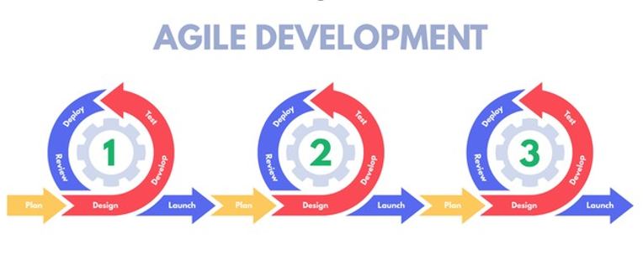

Here are some other SDLC are out there for your information



Why Agile SDLC Model became popular in the market?

Most of the Software projects use Agile SDLC Model for the below reasons:

These days most of the Application like Amazon, Flipkart etc. adapt to the changes in the market very quickly.

Traditional SDLC Models won't adapt to changes quickly and hence are not suitable for these days applications.

Agile SDLC Model become popular in the market, for the medium and large sized Application which evolve over a period of time by quickly adapting to the market needs.

Agile SDLC Model develops the Software over multiple iterations in an incremental manner

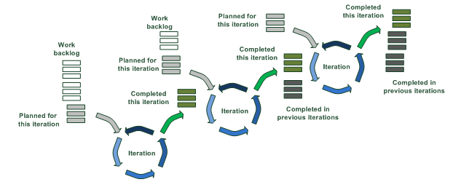

Agile Scrum Methodology

Under Agile, Scrum Methodology is the number one in the market

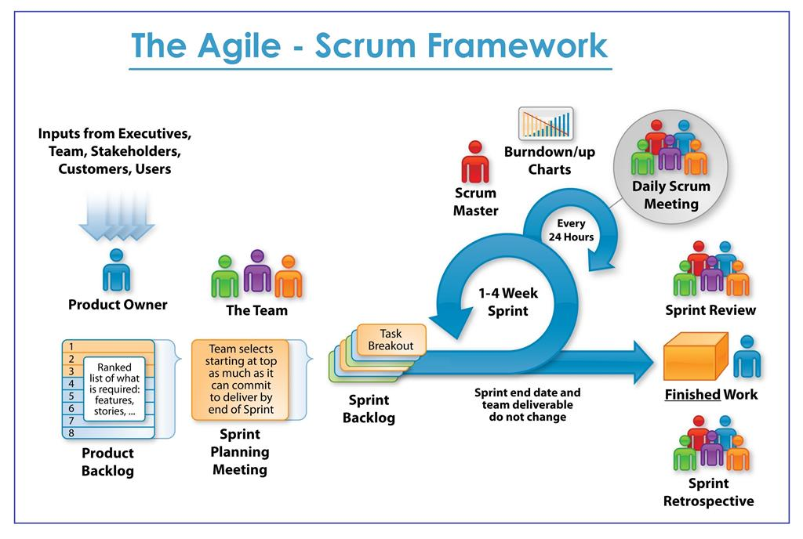

Agile Scrum Framework - Project Process

Scrum follows Agile principles and process

Sprint

Software is developed in iterations known as Sprint

Software will be developed in an incremental manner with few set of requirements for every iteration

Sprint duration is 1 to 4 weeks

Ideal sprint duration is 2 weeks and is followed by most of the projects in real time

Scrum Roles

Product Owner

Scrum Master

Development Team



Product Owner

Product Owner (PO) is client's representative.

Define features of product.

Decide release date and content.

Priorities features according to market value.

Be responsible for the profitability of product.

Accept or reject work items.

Scrum Master

Coach for scrum team.

Enacting scrum values.

Ensure team's productivity.

Build winning team.

Apply agile principles and make system effective.

Team

5-9 Members team (Developer , Tester).

Self-organizing, High performance team.

Build winning product.

Work collaboratively and share responsibilities.

Cross functional team.

Scrum Activities

Sprint Planning

Daily Scrum

Sprint Review

Sprint Retrospective

Product Backlog Refinement

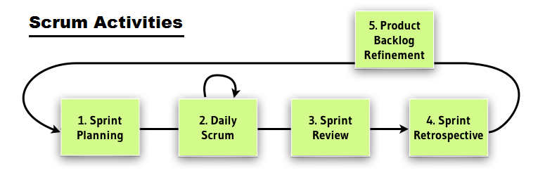

Sprint Planning

Goal: Team to plan and agree on backlog items they can complete and confirm the tasks required to support acceptance.

Who: Scrum Team, Scrum Master, Product owner.

When: Beginning of the Sprint.

Duration: 4 Hours for 2 weeks sprint.

How: In 2 parts.

Part 1: Define what needs to be done.

Part 2: How to achieve goal.

Input: Priority, Product Backlog, Acceptance criteria, Capacity.

Output: Sprint goal, Sprint Backlog, Tasks and their estimates, burn down chart, DOD,

Development plan/ Strategy.

Description

Product owner present the backlog items in priority order for review.

Review and clarify user Backlog items/stories.

Breakdown larger stories and each story into task and acceptance criteria.

Task are estimated in hours by team.

Developer and tester assigned to task.

Process continue until all available hours are used for the sprint.

Output of sprint planning is Sprint backlog, Estimated tasks, etc.

Daily Scrum

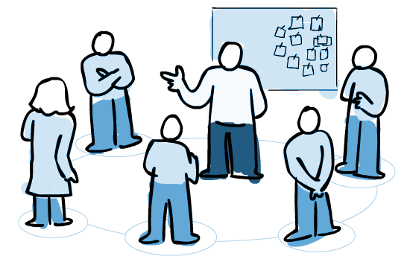

Goal: Plan for the day, Inspect and Adapt daily towards reaching the sprint goal.

Who: Scrum Team, Scrum Master.

When: Daily throughout the sprint.

Duration: 15 minutes maximum.

How: Team members form a group to focus on daily plan, Discuss on issues faced yesterday.

Input: Current status, risks, and done work.

Output: Plan for the day, task to work.

Description:

Daily development Team standup for 15 minutes in circle and talk only on three points.

o What I did since last daily scrum meeting?  
o What I am planning to work on today?  
o Impediments (Issue/blocker) if any?

Scrum master protect the team and facilitate for being effective.

This give an opportunity to team to inspect and adapt daily on the sprint goal.

Sprint Review:

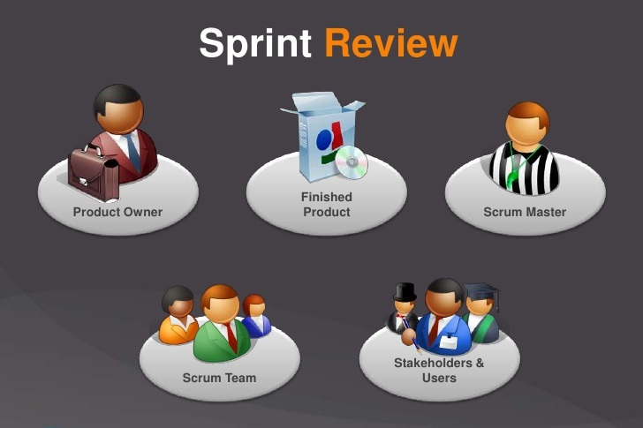

Goal: Get feedback on product development. Inspect and adapt on the product feature.

Who: Scrum Team, Scrum Master, Product owner, Stakeholders.

When: Last day of sprint.

Duration: 2 hours for a 2 week sprint.

How: Demonstrate the working product to all.

Input: Sprint goal, 100% done stories, acceptance criteria.

Output: Acceptance, feedback on demonstrated stories.

Description:

During this meeting team demonstrate 100% completed work.

Scrum master facilitate the environment.

In case any changes or new request, Product owner (PO) note and updates the product backlog as required.

Product owner is final decision maker on acceptance.

Sprint Retrospective:

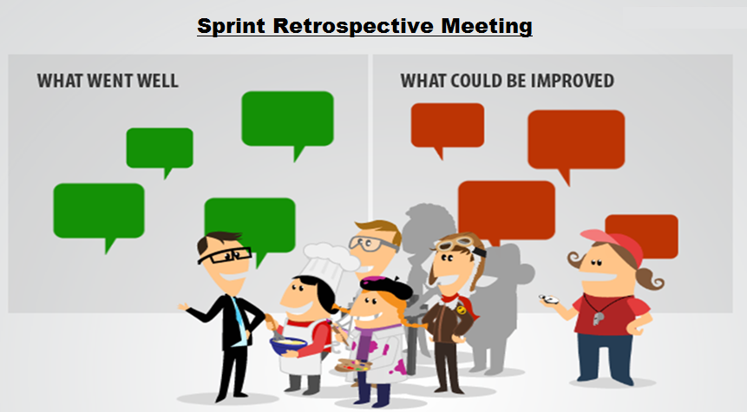

Goal: To inspect and adapt to become more effective and efficient on process, people, culture aspect.

Who: Scrum Team (anyone participation is decided by the scrum team on invite basis only).

When: Last day of sprint.

Duration: 2 hours for a 2 week sprint.

How: Close room discussion of observer pattern and desire results/improvements.

Input: Observation, issues, experience, pattern in behavior, recommendations, feedback and information.

Output: List of activities/steps/suggestions that help to make more effective and efficient. Action items on the team

Description:

Participation in the discussion to inspect and adapt as scrum team.

Scrum master play vital role in sprint retrospective, Scrum master bring in the culture of openness, trust and respect as people discuss the improvement areas, facilitate and focus on improvement and changes that pointing fingers at others.

This is platform to scrum master to help team resolve ineffectiveness in the systems.

Inspect and Adapt: Try everything that makes sense, reject things that didn’t work even after repeated trails. Shape your culture, process and practice.

Product Backlog Refinement:

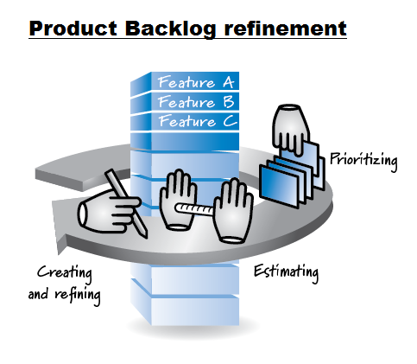

Goal: Keep product backlog items ready, uncertainty to certainty.

Who: Scrum Team, Scrum master, product owner.

When: Continuous process, in between the sprints.

Duration: 1-3 hours depending on the team’s need.

How: priorities the items as per business value. Add, remove, modify existing product backlog item to achieve release scope/goal. Identify and discuss risks, dependencies and other uncertain items in acceptance criteria.

Input: release strategy, priority, product backlog, dependency/risk.

Output: product backlog items 100% ready for future sprint.

Description:

Product owner provide clarity on each product backlog item (All uncertainty clarified into certainty).

Product owner update product backlog. 100% be present and involve all team members.

Team understand, carefully listen to need of product owner, understand the acceptance criteria. Help product owner to order the backlog.

Scrum Artifacts

The following are the Artifacts in Scrum:

Product Backlog

Sprint Backlog

Product Increment

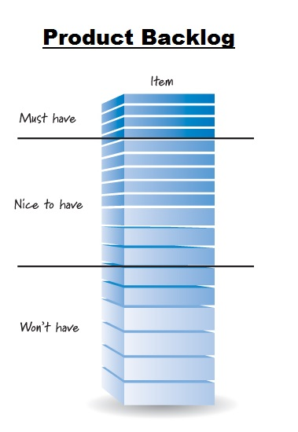

Product Backlog  
  
This is an ordered list of ideas for the product, which can come from the product owner, team members, or stakeholders. A description and estimate of effort complement each product backlog item.The product backlog is ordered to maximize the value delivered by the Scrum team. The development teams work comes from the product backlog, and nowhere else. Every feature, enhancement, bug fix, documentation requirement, every bit of work the team does comes from a product backlog item.The product backlog may begin as a large or short list. Typically it begins short and becomes longer and more defined as time goes on. Product backlog items slated for implementation soon will be "refined," which means they will further clarified, defined, and split into smaller chunks. Though the product owner is responsible for maintaining the product backlog, the development team helps produce and update it.

Sprint Backlog  
  
The sprint backlog is the list of refined product backlog items chosen for development in the current sprint, together with the teams plan for accomplishing the work. It reflects the teams forecast of what work can be completed. Once the sprint backlog is established, the development team begins work on the new product increment.

Product Increment

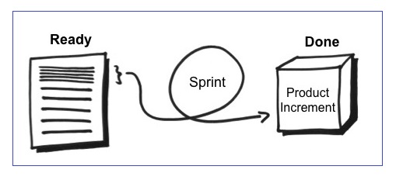

Every sprint produces a product increment, the most important Scrum artifact. A product Increment is the "goal line" for each sprint and, at the end of the sprint, it must:

Be of high enough quality to be given to users.

Meet the Scrum team's current definition of done.

Be acceptable to the product owner.

